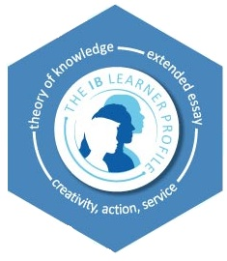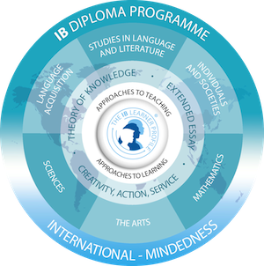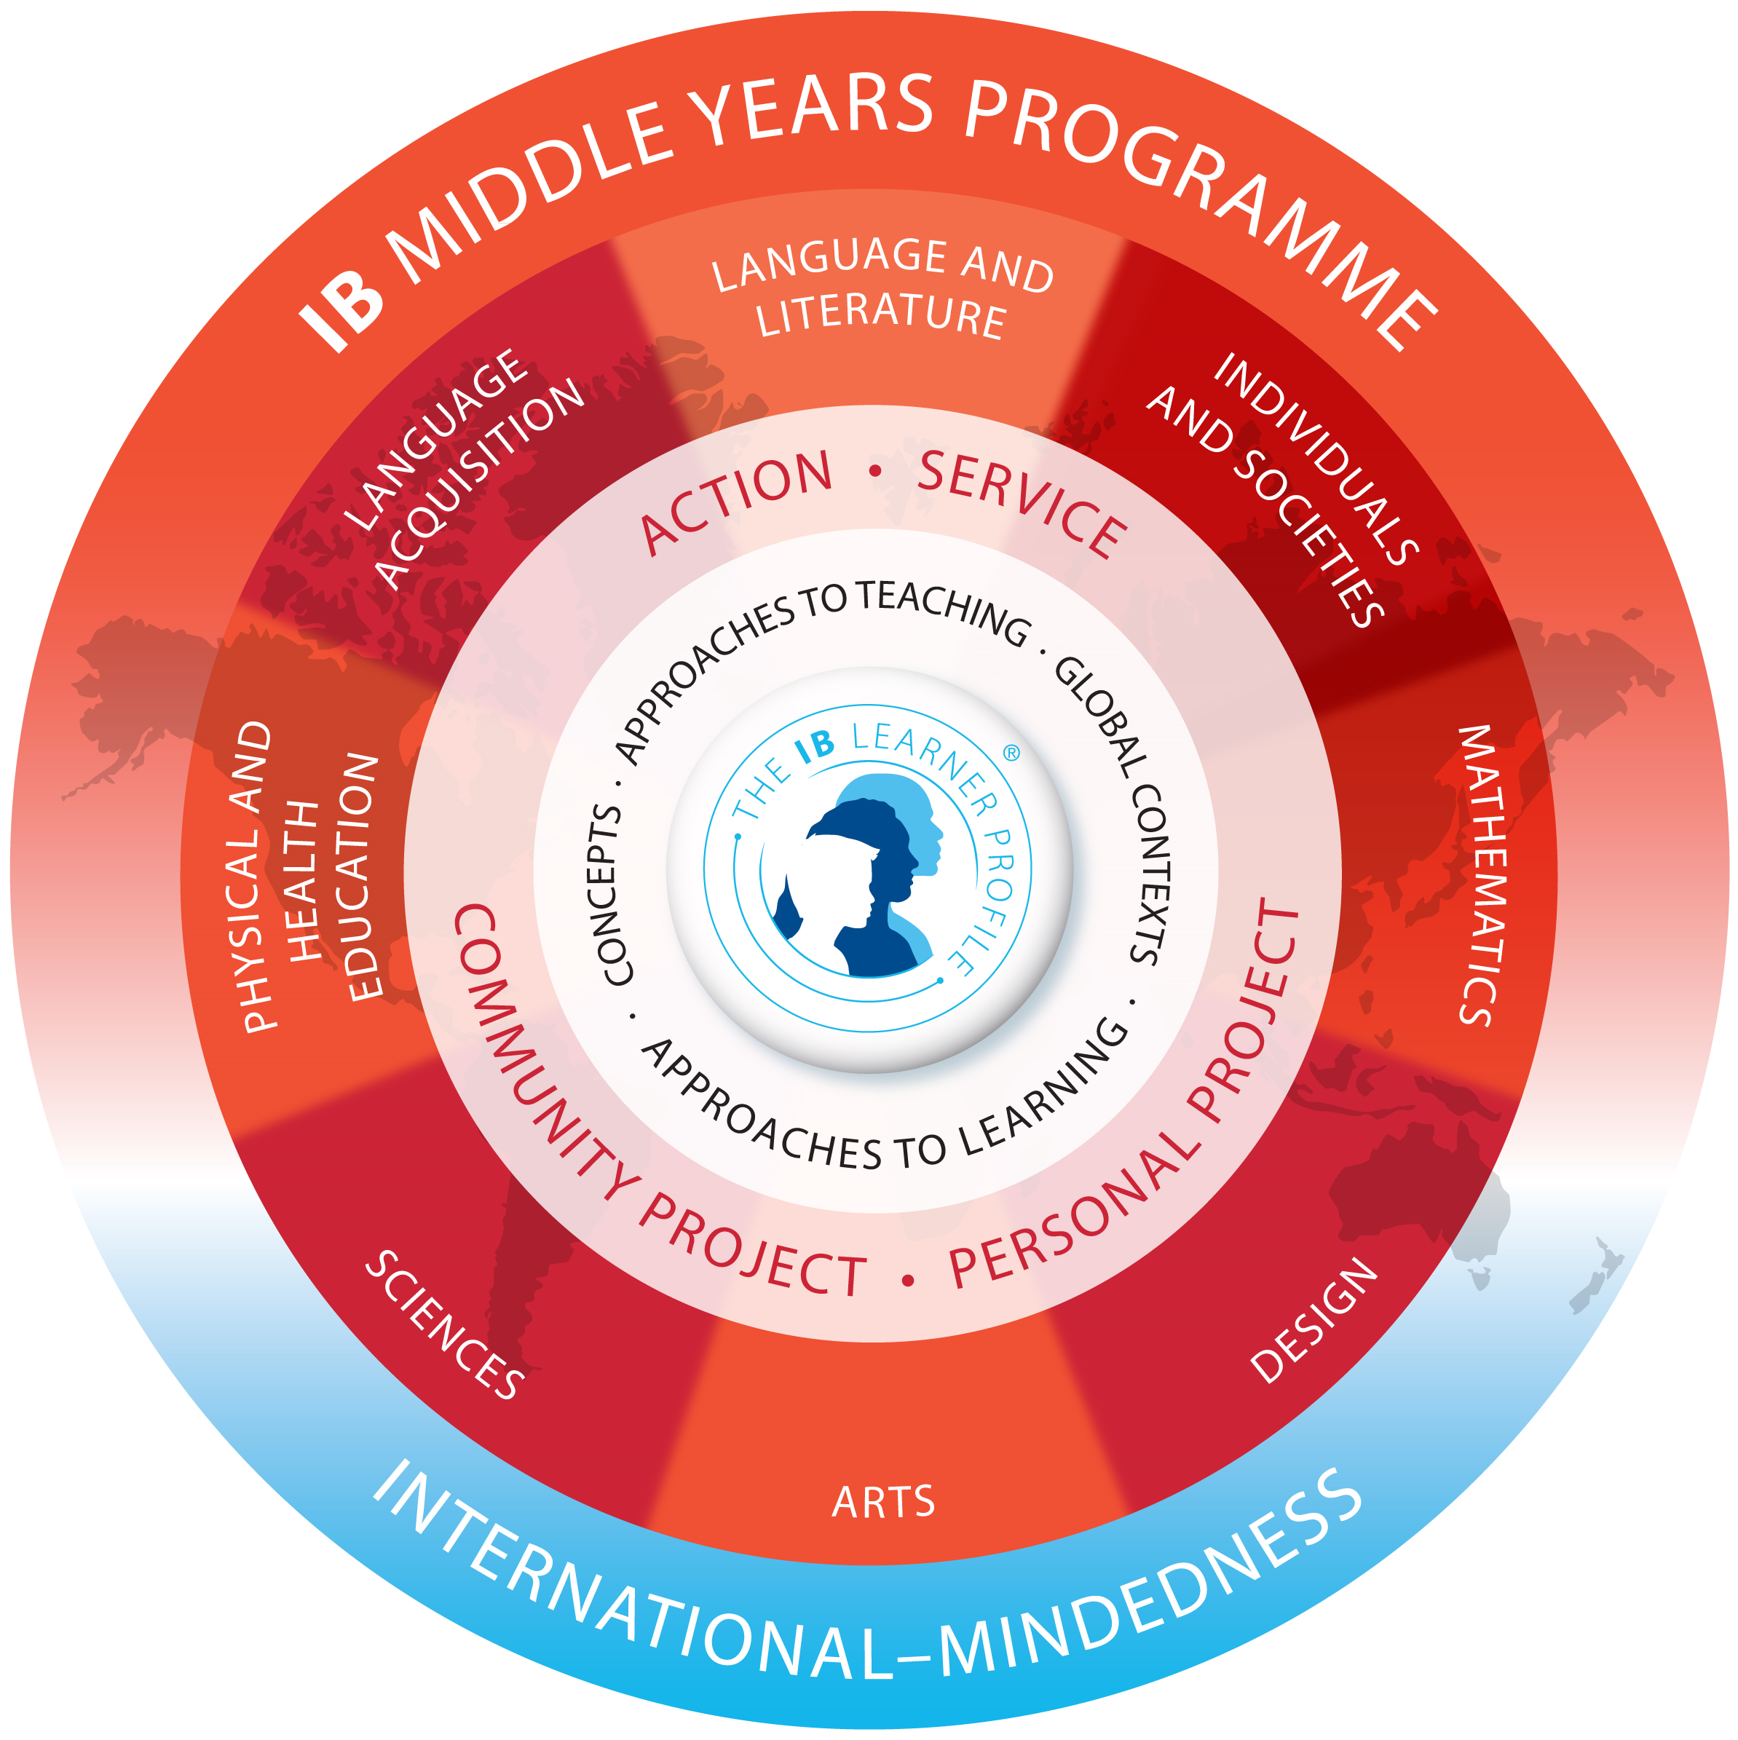

**Wear your purple every Friday!**

#### **September**

Patriot Day

9/11

Hispanic Heritage Month

9/15-10/15

Constitution Week

9/17-9/23

The Panther PRess

We are moving to a 21st century collaboration center where multiple classes can work on interdisciplinary projects, students can get together to share ideas, collaborate on multi-media projects and publish their work. ALL of the earnings from our Principal’s Fundraiser that we are kicking off on September 14th will go to these renovations. Please see [the flyer](http://padlet.com/rcardina1/MYPFamilyandStudentInfo) with all the information about turn in dates, online options and the fun things your child can earn while supporting PVMS. The grade level that earns the most money will have a special honor that will remain at PVMS for years to come. Please click [here](http://padlet.com/rcardina1/MYPFamilyandStudentInfo) to be taken to our MYP Padlet for Students and Families to see the PVMS Media Redesign presentation reflecting our vision.

FINAL fundraiser money due!

9/28

#### **October and November**

10/22

6:30 P.M. Parent University

11/17

PVMS Great American Teach-In. Please contact Ms. John if you would like to be a speaker!

Picture Day! Pictures will be taken during math class.

9/21

9/25

Progress Reports

**Pink Out every Wednesday!**

## PVMS is updating the Media Center with your help!

Learner Profile of the Month: Principled

### Upcoming events

As a PVMS Family, we will focus on a different Learner Profile every month. For September, we are focusing on being Principled. We are principled when we act with integrity and honesty and take responsibility for our actions. PVMS staff members have purple “#IBPrincipled” tickets that they are giving out throughout the month to students who are acting in a principled manner. At the end of the month, all students who earned an #IBPrincipled ticket will be entered into a drawing to earn a prize.

Teachers will also be choosing students for “Student of the Month” who are an example to others in exemplifying that they are principled.

We are encouraging all Panthers to wear the color of the month, purple, on Friday, September 18th.

##### 5334 Parkway Blvd., Land O’ Lakes, FL 34639

##### <http://pvms.pasco.k12.fl.us/> T: 813-794-4800

# Pine View Middle School

The IB offers three programs in addition to the MYP: the Diploma Programme (DP), the Career-related Programme (CP) and the Primary Years Programme (PYP).

Many of you may be familiar with the Diploma Program, which is offered in Pasco County at both Land O’ Lakes High School and Gulf High School. The DP is an application program for students aged 16-19 who, upon successful completion of specific standards, are eligible to earn an IB Diploma. The MYP, with its focus on inquiry-based learning and the infusion of the Learner Profiles, prepares students for whichever path they choose in both high school and life.

For more information about the Diploma Programme for your 8th grade student, please plan to attend the Parent Information Night listed above and/or visit ibo.org through [this](http://www.ibo.org/en/programmes/diploma-programme/what-is-the-dp/) link.

## What other programs does the IB offer? Diploma Programme focus

The International Baccalaureate Diploma Programme offers high achieving, high-performing students an opportunity to pursue a rigorous program of studies during their high school years. The academic requirements of the IB program are demanding. However, the student with an IB diploma or certificate may be awarded college credit and advanced standing at colleges and universities throughout the world. LOLHS also offers the Career-related Programme, which we will highlight in next month’s newsletter.

The IB Program at Land O’ Lakes High School serves east side and central schools in Pasco County. Parent Information nights will be held in November and are open to the public. A link to the application will be available on line at <http://lolhs.pasco.k12.fl.us> at the International Baccalaureate link beginning October 5th.

What: IB Diploma Programme Information Night

When: November 10, 2015 from 6:30-7:30 pm

Where: Land O’ Lakes High School

LOLHS Diploma Programme Information

What does this model mean? Please click [here](https://www.youtube.com/watch?v=iZPi2-x0zkc) or scan the QR code below for a video about the Programme models of the IB.

# What are the eight subject areas in the MYP?

The eight subject areas in the MYP are Language and Literature, Mathematics, Sciences, Individuals and Societies, Arts, Design, Physical Education and Health and Language Acquisition. Some of these terms have not changed from traditional middle school classes, but others have. Please see the table below for clarification.

|  |  |
| --- | --- |
| **IB Course** | **Traditional Course** |
| Language and Literature | Language Arts |
| Mathematics | Mathematics |
| Sciences | Science |
| Individuals and Society | Social Studies |
| Arts | Art, Band, Chorus, Drama |
| Design | CTE (Career and Technical Education) |
| Physical Education and Health | Physical Education |
| Language Acquisition | Foreign Language |

PVMS Social Media and Helpful Links

Instagram: pvmsmyp

Twitter: @pineviewmiddle

Facebook: Pine View Middle School

[International Baccalaureate](http://www.ibo.org)

[MYP Padlet for Students and Families](http://padlet.com/rcardina1/MYPFamilyandStudentInfo)

[PVMS MYP YouTube video](https://www.youtube.com/watch?v=2-WwhtZyRSw)

Do you want to assist students with community service opportunities? Volunteer to support future MYP projects? Know of community service opportunities? Please join the PVMS Community Outreach Committee by scanning the code above!

Looking for local and charity events in Pasco? Click the QR code above to go to www.visitpasco.net

Pasco County, FL Events

Questions?

Please contact our IB Coordinator:

Becky Cardinale

[rcardina@pasco.k12.fl.us](mailto:rcardina@pasco.k12.fl.us)

### #IBINVOLVED

A HUGE thank you to our local businesses who support us. If you own a business or know of one who would like to support our school, please contact [Becky Cardinale.](mailto:rcardina@pasco.k12.fl.us)

***Thank you*** to our supporters:

**Lake Wilderness Beef O’ Brady’s**

**Moe’s Southwest Grill Land O’ Lakes**

**McDonald’s- Land O’ Lakes (and partner restaurants)**

**M**

Support our supporters!

Students in our hybrid world geography class create, produce and upload the PVMS news program to our YouTube channel daily. Click [here](https://www.youtube.com/channel/UCLl9NEO1U3xmUiG348DRsUg) or scan the QR code to watch the PVMS news!

PVMS has a student produced news program!

#### PVMS Community Outreach Committee