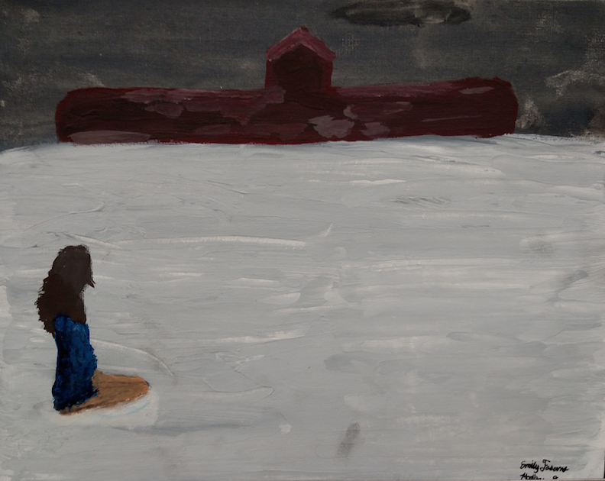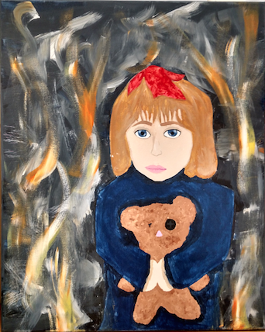

**May**

5/11, 12, 13 Spring Play

5/16-19 Cheerleading Tryouts

5/19 PVMS Art Fest- More info inside!

5/20 Last day for My School Bucks payments in the cafe

5/26 FFA Banquet

5/27 Year 3 Dance   
School District Employee Take Your Child to Work Day

5/30 Memorial Day (no school)

**June**

6/2 Spring Concert

6/6 Awards Day

6/8 Last Day of school  
Year Three Field Day

**August**

8/9 Secondary Orientation

8/15 First day of school for students

**Pink Out EVERY Wednesday!**

### Upcoming events

Learner Profile of the Month: Inquirers

As a PVMS Family, we will focus on a different IB Learner Profile every month. For May, we are focusing on being *Inquirers.* We are *Inquirers* when are naturally curious and enjoy researching new things. PVMS staff members have green “#IBStrong” tickets that they are giving out throughout the month to students who are *Inquirers.* Students who earn a ticket will be entered into a drawing to earn a prize, which will be featured on our school news at least twice per month. Teachers will also be choosing students for “Student of the Month” who are an example to others in exemplifying that they are *Inquirers*.

##### 5334 Parkway Blvd. Land O’ Lakes, FL 34639

##### www.pvms.pasco.k12.fl.us

the panther press

# *Pine View Middle School*

**Adventure Society is traveling to COSTA RICA!**

Join us in June of 2017 for an exciting group trip to Costa Rica! We will be zip lining, white water rafting, kayaking, horseback riding, visiting waterfalls, volcanoes, hot springs, and even a local school. This adventure is an all inclusive trip with EF Tours for both students and adults.

For more information and pricing, plan to attend our informational meeting on **June 1st at 6:00 PM** in the PVMS media center. You can also see Ms. Arrington in room 701 or check out our tour website below!

<http://www.eftours.com/tour-website/1820347VJ>



Adventure Society is NOT a school or district affiliated group.

## #**IBInvolved**

**PVMS Art Fest**

**Where:** 5/19 in the PVMS Cafeteria

**When:** 4-7 PM

**Details:** There will be artwork, a talent show, cupcake decorating contest, music and more!

**Cost to enter is free but please bring cash to buy food and souvenirs.**

As part of our Holocaust unit, several of Dr. Krell’s students entered their final projects into the Yom HaShoah Student Creative Arts Contest with the Holocaust Memorial Resource and Education Center of Florida. Entries were in different categories—2D and 3D art, poetry, essay, and narrative—and they competed against other students across the state. We’re delighted to announce that Pine View Middle School was the home to three of the winners!

Emily Fasano & Madison Dunn—2nd place in art for their mixed media painting (girl kneeling in snow)

Katelyn Sellers—3rd place in art for her painting (girl with teddy bear)

**Yom HaShoah Student Creative Arts Contest**

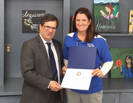

In conjunction with Teacher Appreciation Week, Congressman Gul Bilirakis sought nominations from the community for the District 12 Teachers of the Year. Four Pasco County teachers were selected, one of which is Pine View Middle School’s **Jennifer Craven**! She was presented with a certificate and the Congressional coin. Congratulations!!

**Congressional District 12 Teacher of the Year**

## **Year 3 End of Year Activities**

PVMS Social Media and Helpful Links

PVMS Website: <pvms.pasco.k12.fl.us>

Instagram: pvmsmyp

Twitter: @pineviewmiddle

Facebook: Pine View Middle School

[International Baccalaureate](http://www.ibo.org)



**Awards Day**

June 6th will be the awards day for Year 1, 2 and 3 students. Parents whose children are getting an individual award will be notified prior to the 6th with specific information.

**My School Bucks**

Parents will no longer be able to make deposits into MySchoolBucks as of May 20th, 2016 because it is time to process the MySchoolBucks accounts for the end of this school year.

If you need to apply funds to your child’s account, you may do so by sending in cash or a check made payable to PVMS. Please make sure your telephone number, your child’s name and your child’s student number are on the check. Thank you for your understanding!

It’s hard to believe that our Year 3 students have been with us for almost three years! We are excited about the activities we have planned for them and hope that they make wonderful memories these last couple months of middle school. We are offering a combined ticket for the Year Three Field Day and Year Three Dance, as well as a la carte options. Please see our website at <http://pvms.pasco.k12.fl.us/5468-2/> for ordering information.

Year Three Dance: May 27th at Land O’ Lakes High School

Year Three Field Day: June 8th at PVMS

Important Links

PVMS Website: <pvms.pasco.k12.fl.us>

Instagram: pvmsmyp

Twitter: @pineviewmiddle

Facebook: Pine View Middle School

[International Baccalaureate](http://www.ibo.org/)

**Support our Supporters!**

A HUGE thank you to the local businesses that support PVMS. If you own a business or know of one who would like to support our school, please contact [Becky Cardinale](mailto:rcardina@pasco.k12.fl.us).

***Thank you*** to our supporters:

**Optimum Plumbing-** Thank you for your very generous gift card donation for our Students of the Month!

**Get a Grip Total Fitness-** Thank you for your very generous gift card donation for our Students of the Month!

**Wendy’s-** Thank you for the Super Student Awards and Frosty coupons!

**Cobb Theatres-** Thank you for the complimentary movie passes!

**Lake Wilderness Beef O’Brady’s-** Thank you for the Merit and Achievement Awards!

**Moe’s Southwest Grill Land O’ Lakes-** Thank you for the certificates and the supplies!

**McDonald’s- Land O’ Lakes (and partner restaurants)-** Thank you for the Chicken McNugget vouchers!

**Sugardarlings Cones and Cupcakes-** Thank you for the cupcake vouchers!