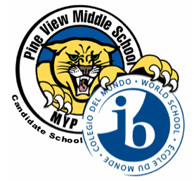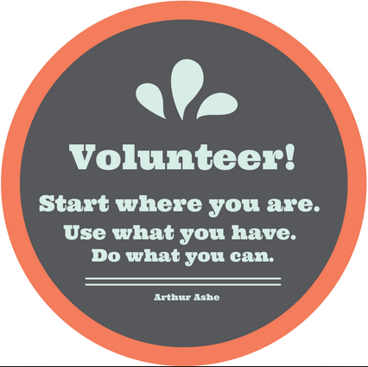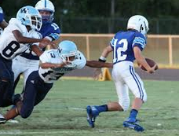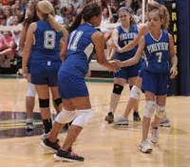

The Panther Press

12/9, 10, 11 Winter Plays in the PVMS Media Center. See article for details.

12/11 Winter Concert Fundraiser 2:00-2:50

12/18 Holiday Hat Day!

12/21- 1/4 Winter Break-   
No school

**January**

1/14 End of 2nd quarter and 1st semester

1/15 No school- Teacher Planning Day

1/18 No school- Dr. Martin Luther King Day

1/25 Report Cards

December Learner Profile of the Month:  
Open-minded

As a PVMS Family, we will focus on a different Learner Profile every month. For December, we are focusing on being *Open-minded*. We are *Open-minded* when we understand and appreciate our own cultures and personal histories and are open to the perspectives, values and traditions of others. PVMS staff members have green “#IBOpen-minded” tickets that they are giving out throughout the month to students who are *Open-minded*. At the end of the month, all students who earned a ticket will be entered into a drawing to earn a prize. Teachers will also be choosing students for “Student of the Month” who are an example to others in exemplifying that they are *Open-minded*.

##### 5334 Parkway Blvd, Land O’Lakes, FL 34639

##### <pvms.pasco.k12.fl.us> T: 813.794.4800

**December**

#### Pink Out every Wednesday!

### Upcoming events

# Pine View Middle School

On December 4th, our PVMS MarchingBand, under the direction of Ms. Barbosa, marched in the Dade City Holiday Parade.

On December 11th, the PVMS Advanced Band, Chorus and Show Choirwill play at our annual Winter Concert.  The Winter Concert is an ABC fundraiser where we collect canned or boxed food items for our ABC families.  Students who want to participate will be asked to bring in 2 food items and $2.00.  We will start collecting food and money during the week of December 7. Students may bring their items to the guidance office as soon as they arrive to school.

On the day of the concert, students who donate to the fundraiser will be given an elf hat during 5th period. The “elf hat” will be their “ticket” to the fundraiser.

**Musical Happenings**

We are excited to invite you to our winter plays, *Surviving Adolescence: A Night of One Act Plays,* on December 9th, 10th and 11th. Doors open at 6:00 and the plays begin at 6:30. Tickets are $3 at the door. Our PVMS actors and actresses have worked tirelessly under the direction of Ms. Behner to make this year’s performances truly a night to remember.

**The Arts are Alive at PVMS!**

## **Winter One Act Plays**

#IBInvolved: Water for South Sudan

Through the study of Linda Sue Park’s dual-narrative, *A Long Walk to Water,*Sixth-graders are conducting an in-depth study of the political, social, and cultural climate of South Sudan.   *"A Long Walk to Water begins as two stories, told in alternating sections, about two eleven-year-olds in Sudan, a girl in 2008 and a boy in 1985. The girl, Nya, is fetching water from a pond that is two hours’ walk from her home: she makes two trips to the pond every day. The boy, Salva, becomes one of the "lost boys" of Sudan, refugees who cover the African continent on foot as they search for their families and for a safe place to stay. Enduring every hardship from loneliness to attack by armed rebels to contact with killer lions and crocodiles, Salva is a survivor, and his story goes on to intersect with Nya’s in an astonishing and moving way.”*  While reading this dual-narrative, students will focus on Author’s Craft as well as the ways in which Point-of-View and Setting change perspectives of fairness and developments in the world.

To make the text-to-life connection, PVMS will take part in the Water for South Sudan Iron Giraffe Challenge.  Water for South Sudan is a not-for-profit organization founded by Salva Dut whose focus is “Drilling Wells, Transforming Lives.”  Last year, PVMS raised enough money to place third internationally in this challenge.  As a reward for our efforts, Salva Dut personally SKYPED PVMS all the way from South Sudan.  This was an amazing opportunity for our students.  To learn more about this organization, visit <http://www.waterforsouthsudan.org>.

## Calling all volunteers!

Thank you for your interest in volunteering at Pine View Middle School! There are many opportunities for approved volunteers in our school from chaperoning field trips to assisting in the classroom to supporting our incentive program by handing out rewards in the Panther Pit. If you are interested, please contact the school at 813-794-4800.

No act of kindness, no matter how small is ever wasted. -Aesop

**PVMS Social Media and Helpful Links**

PVMS Website: <pvms.pasco.k12.fl.us>

Instagram: pvmsmyp

Twitter: @pineviewmiddle

Facebook: Pine View Middle School

[International Baccalaureate](http://www.ibo.org)

**Support our Supporters!**

A HUGE thank you to the local businesses that support PVMS. If you own a business or know of one who would like to support our school, please contact [Becky Cardinale](mailto:rcardina@pasco.k12.fl.us).

***Thank you*** to our supporters:

**Optimum Plumbing**- Thank you for your very generous gift card donation for our Students of the Month!

**Get a Grip Total Fitness-** Thank you for your very generous gift card donation for our Students of the Month!

**Wendy’s-** Thank you for the Super Student Awards and Frosty coupons!

**Cobb Theatres-** Thank you for the complimentary movie passes!

**Lake Wilderness Beef O’ Brady’s-** Thank you for the Merit and Achievement Awards!

**Moe’s Southwest Grill Land O’ Lakes-** Thank you for the certificates and the supplies!

**McDonald’s- Land O’ Lakes (and partner restaurants)**- Thank you for the Chicken McNugget vouchers!

**Sugardarlings Cones and Cupcakes**- Thank you for the cupcake vouchers!

Our Girls Basketball and Boys Soccer teams have begun their season! Please see our school calendar for practice and game schedules on the PVMS website.

Come on out to cheer on our Panthers!

**Athletics**