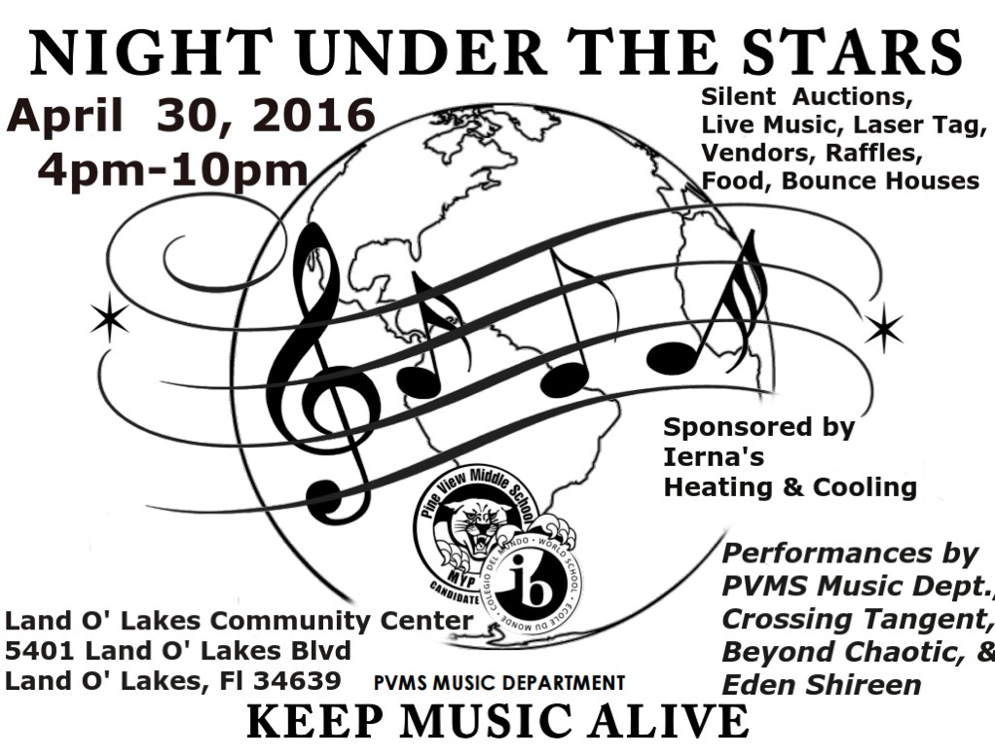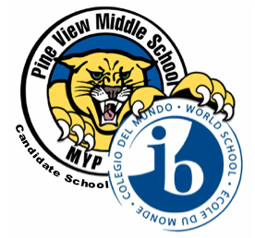

**April**

4/11-5/6 FSA Testing window

4/14 Track Conference meet @WRHS

4/20 2017-2017 Year 2 and 3 Parent Night (current Year 1 and 2 students)

4/22 Course selection cards due

4/30 Night Under the Stars Music Festival

**May**

5/11, 12, 13 Spring Play- See information p. 5

5/19 PVMS Art Fest- More info inside!

5/26 FFA Banquet

5/27 Year 3 Dance   
School District Employee Take Your Child to Work Day

5/30 Memorial Day (no school)

**June**

6/2 Spring Concert

6/8 Last Day of school  
Year Three Field Day

**Pink Out EVERY Wednesday!**

### Upcoming events

Learner Profile of the Month: Communicators

As a PVMS Family, we will focus on a different IB Learner Profile every month. For April, we are focusing on being *Communicators.* We are *Communicators* when we express ideas and information confidently, often on more than one language. We work well with others. PVMS staff members have yellow “#IBStrong” tickets that they are giving out throughout the month to students who are *Communicators.* Students who earn a ticket will be entered into a drawing to earn a prize, which will be featured on our school news at least twice per month. Teachers will also be choosing students for “Student of the Month” who are an example to others in exemplifying that they are *Communicators*.

##### 5334 Parkway Blvd. Land O’ Lakes, FL 34639

##### www.pvms.pasco.k12.fl.us

the panther press

# *Pine View Middle School*

**Come support our PVMS music programs!**

See the flyer to the right for more information or visit our PVMS Facebook page.

It’s hard to believe that our Year 3 students have been with us for almost three years! We are excited about the activities we have planned for them and hope that they make wonderful memories these last couple months of middle school. We are offering a combined ticket for the Year Three Field Day and Year Three Dance, as well as a la carte options. Please see our website at <http://pvms.pasco.k12.fl.us/5468-2/> for ordering information.

Year Three Dance: May 27th at Land O’ Lakes High School

Year Three Field Day: June 8th at PVMS

## **Year 3 End of Year Activities**

**PVMS Art Fest**

**Where:** 5/19 in the PVMS Cafeteria

**When:** 4-7 PM

**Details:** There will be artwork, a talent show, cupcake decorating contest, music and more!

**Cost to enter is free but please bring cash to buy food and souvenirs.**

## #**IBInvolved**

**Staff Choice Awards:**

**September:** Sarah Szymanski

**October:** Hal Dana

**November:** Nicole John

**December:** Becky Cardinale

**January:** Michelle Kennon

**February:** Nilsa Calabria

**March:** Sandy Dinehart

**Kid’s Choice Awards:**

**September:** Gaylene Gay

**October:** Jim Sawl

**November:** Annette Worley

**December:** Veronica Steiner

**January:** Sue Bach

**February:** David Starkey

**March:** Chrissy Arrington

# Celebrating our Staff: Staff Members of the Month

For parents employed by Pasco County Schools:

District employees who wish to bring their son or daughter to work with them may do so on Friday, May 27.  Employees also must prearrange their children’s absences with their principals and teachers if they plan to participate on May 27. They also must get approval from their site administrator. Schools  and departments should use their newsletters and other platforms for communicating with parents to let them know their responsibilities.  Take Your Daughters and Sons to Work Day generally is for elementary- and middle school-age children.

For parents **not** employed by Pasco County Schools:

The national Take Your Daughters and Sons to Work day is scheduled for Thursday, April 28. That day falls during state end-of-course exams.  With this in mind, we will use the same process we’ve used the past couple of years for parents who wish to take their children to work with them at their place of employment outside the district.  A principal has the discretion to allow a parent to take his or her son or daughter out of school to participate in the national event if the student does not have a scheduled EOC on Thursday, April 28, AND the parent has prearranged the student’s absence with his or her principal and teacher(s).

**Take Your Child to Work Day**

###### Continued…

**PVMS Athletics**

Cheerleading

Any Year One or Year Two student interested in trying-out for cheerleading for the 2016-2017 school year should see Ms. Arrington in room 710 by May 6th, 2016 to get the necessary paperwork.

**Exploravision**

Our Year 3 Panthers took place in the international STEM competition, ExploraVision, sponsored by the National Science Teachers Association (NSTA) and Toshiba.  70 of the more than 30,000 projects this year were submitted by our Panthers.  We are excited to announce we have two honorable mention teams.  To qualify for honorable mention, teams’ scores are in the top 10% of all scores.   Congratulations to Eesha Patel and Rihana Aydin from Mrs. Buckalew’s class for their C.A.L.E. Chip (Cancer Antigen Level Exhibitor) and Ashley Crawford and Kylie Roberts from Mrs. Holyoke’s class for the Brace Face.  Way to go, Panthers!

**Year Two and Year Three Parent Information Night**

PVMS will be hosting rising Year Two and Year Three (current Year One and Year Two) students and families on Wednesday, April 20th. We will be sharing information on our Middle Years Programme journey and Year Two and Year Three teachers will be showcasing their curriculum. Please see the post on our website [here](http://pvms.pasco.k12.fl.us/parent-information-night-years-2-3/) for additional information. You may return your course selection cards at the Parent Night or on Friday, April 22.

PVMS Social Media and Helpful Links

PVMS Website: <pvms.pasco.k12.fl.us>

Instagram: pvmsmyp

Twitter: @pineviewmiddle

Facebook: Pine View Middle School

[International Baccalaureate](http://www.ibo.org)

#### Walking Challenge!

#### Pasco County Schools has invited all interested employees to walk 10,000 steps every day for 16 weeks.

#### Why not have a walking challenge in your family? Make sure you’re medically cleared for exercise and then the sky is the limit. Think of the great conversations you can have with your children if you go on a walk after dinner!

#### You can do it, Panthers!



**Spring Play!**

**What**: “Who’s in Charge?” Or “Rodney, the Ultimate Gift to Theater” by E. Jack Williams

**When:** May 11-13 (Wednesday-Friday)

**Time**: 6:30 PM (Doors open at 6 PM)

**Where:** PVMS Media Center

**Cost:** $3 at the door

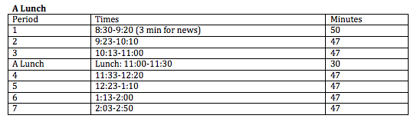

2016-2017 PVMS School Hours/Schedule

We are excited to share that we are moving to a seven period day for the next schedule year. The seven period day allows us to fully implement all eight core areas of the Middle Years Programme.

Below is an example bell schedule for a student with “A” lunch:

Important Links

PVMS Website: <pvms.pasco.k12.fl.us>

Instagram: pvmsmyp

Twitter: @pineviewmiddle

Facebook: Pine View Middle School

[International Baccalaureate](http://www.ibo.org/)

**Support our Supporters!**

A HUGE thank you to the local businesses that support PVMS. If you own a business or know of one who would like to support our school, please contact [Becky Cardinale](mailto:rcardina@pasco.k12.fl.us).

***Thank you*** to our supporters:

**Optimum Plumbing-** Thank you for your very generous gift card donation for our Students of the Month!

**Get a Grip Total Fitness-** Thank you for your very generous gift card donation for our Students of the Month!

**Wendy’s-** Thank you for the Super Student Awards and Frosty coupons!

**Cobb Theatres-** Thank you for the complimentary movie passes!

**Lake Wilderness Beef O’Brady’s-** Thank you for the Merit and Achievement Awards!

**Moe’s Southwest Grill Land O’ Lakes-** Thank you for the certificates and the supplies!

**McDonald’s- Land O’ Lakes (and partner restaurants)-** Thank you for the Chicken McNugget vouchers!

**Sugardarlings Cones and Cupcakes-** Thank you for the cupcake vouchers!