Step #1 | Go to Pasco County Schools, and choose Parents on the top of the screen. Then choose the green tab on the left side of your screen, Check Grades Attendance | 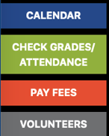
Step #2 | Sign into your parent account, if you do not have an account you will follow the directions to setting one up. | 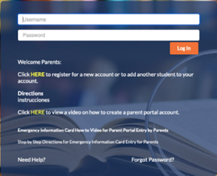
Step #3 | Upon signing in, you will see a notice that you have pending forms with your child(ren) listed individually. | 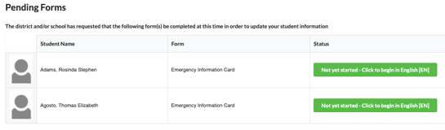
Step #4 | There are 9 total pages that are short and simple to complete with questions like verifying your address, medical contacts, emergency contacts, custody issues, etc. You can save and come back or choose next page to continue through. | 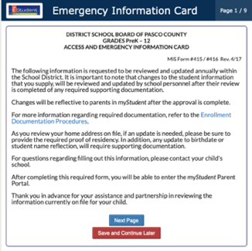
Step #5 | Hint Hint Hint!!!!  In order to continue through you must enter the information, click return/enter and then save. If the save button is not bright red, you are missing something and you cannot move on. | 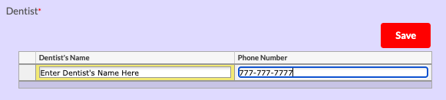
Step #6 | After you have submitted, if you have more children you will be promoted to return to the notice screen to complete the same form for your next child. If you only have one child, you are done! | 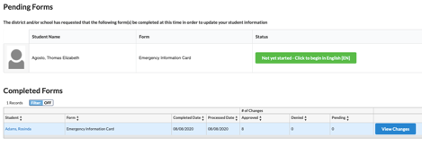
Step #7 | If you need detailed directions through each page please watch this video or read this handout provided by District Office.
Step #8 | After completing the Emergency Card, you will be asked to answer a short Wellness Survey as a Parent. Students will also have a Wellness Survey to complete in their student portal. | 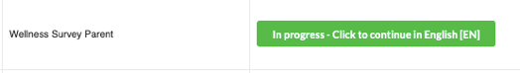

Contact myStudenthelp@pasco.k12.fl.us if you have any questions.

