Step #1 | Go to Pasco County Schools, and choose students on the top of the screen. Then choose the orange tab on the left side of your screen, myPasco Connect | 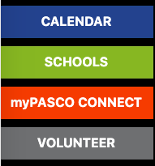
Step #2 | Log onto your child’s myPasco Connect Dashboard | 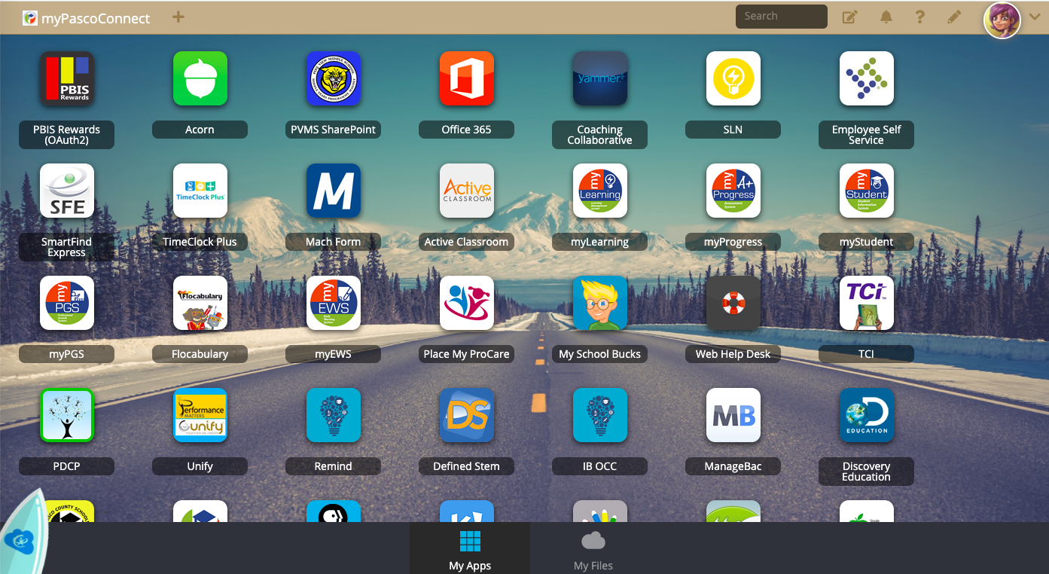
Step #3 | Choose myLearning (Canvas) and log in using your child’s student number and “funky” password (remember the first letter is always capitalized)  If you do not know your password, check out the accessing your password handout. | 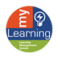
Step #4a | All New Panthers choose the All Paws In (API) course | 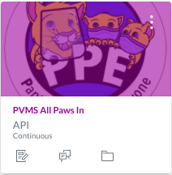
Step #4b | All returning Panthers choose the Panthers Protecting Everyone (PPE) course | 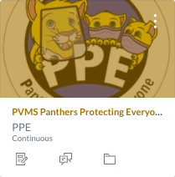
Step #5 | As a family, complete the 9 modules in any order you choose. The only way you can access the 10th and final Module is by reading through and acknowledging the other 9 modules. | 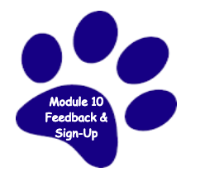
Step #6 | Mark your calendar for Meet the Teacher Day on August 19th either face-to-face or virtually.

