Pine View Middle School is excited to offer our Panther families a Virtual Orientation Day option on Tuesday, August 6. This unique and innovative option will encompass an opportunity to pay fees, purchase Panther spirit gear, and preview schedules, as well as "Meet and Greet" your child’s teachers. This "Meet and Greet" opportunity will take the place of a traditional Open House evening.

The options presented below are in no way mandatory, simply considerations for families to begin their school year in a manner that preserves your time.

Is your child a previous PVMS student who would like to get his or her schedule without visiting before the first day of school? Does your schedule conflict with the Orientation Day on August 6th?
- Complete the 3 P’s (Pay, Preview and Print) online registration on August 6th (see the panther paw below)
Pay school fees using ACORN Preview schedule Print schedule and ACORN Receipt

- If you purchase Panther spirit gear, PE uniforms, etc. send the printed receipt with your student to bring the first day of school, August 12th.
- You have completed your virtual orientation!

Are you new to PVMS, or a current Panther family who would like to walk your student's new schedule and meet his or her teachers? See the options below:

Option 1: Facilitate orientation virtually through the online platform then physically walk the building

Year 2** and 3 Families:
- Facilitate the 3 P’s (Pay, Preview and Print) virtual orientation on August 6th (see the panther paw below)
Pay school fees using ACORN Preview schedule Print schedule and ACORN Receipt

**TDaP immunization must be on file with PVMS so that it does not interfere with the virtual orientation process. Click here for the Immunization Event Flyer.
- Come to PVMS on August 6th from 1:30-3:00pm to “Meet and Greet” your teachers!
- If you ordered Panther spirit gear or PE uniforms online, be sure to bring your printed receipt and pick them up in the gym from 1:30pm-3:00pm
- Optional: Bus Pass Change (add or change a bus pass)
  - Call our Transportation Office (813) 794-0528, or
  - Meet with a representative from our Transportation Office in the PVMS gym from 1:30PM-3:00PM.

Year 1 Families:
**If you attended the All-Paws In event on August 1st, you do not need to facilitate the directions below. You are always welcome to come back to campus to walk your student’s schedule with them for extra practice at the Year 1 time 12:00-1:30 pm! 😊 **
Facilitate the 3 P’s (Pay, Preview and Print) virtual orientation on August 6th (see the panther paw below)
- Pay school fees using ACORN
- Preview schedule on myStudent
- Print student schedule and ACORN Receipt
- Come to PVMS on August 6th from 12:00-1:30pm to “Meet and Greet” your teachers!
- If you ordered Panther spirit gear or PE uniforms online, be sure to bring your printed receipt and pick them up in the gym from 12:00-1:30pm.
- Optional: Bus Pass Change (add or change a bus pass)
  - Call our Transportation Office (813) 794-0528, or
  - Meet with a representative from our Transportation Office in the PVMS gym from 12:00PM-1:30PM.

Option 2: Facilitate orientation at PVMS on Orientation Day and physically walk the building
- Facilitate Orientation Day at PVMS on August 6th to complete the orientation process. To Pay fees and get schedules, Year 1 should come to the gym at 12PM-1:30PM and Years 2 and 3 should come to the gym from 1:30PM-3PM.
- Participate in “Meet and Greet” with Year 1 teachers from 12:00PM-1:30PM or Years 2 and 3 teachers from 1:30PM-3:00PM.
- Optional: Bus Pass Change (add or change a bus pass)
  - Call our Transportation Office (813) 794-0528, or
  - Meet with a representative from our Transportation Office in the PVMS gym. Year 1 – 12:00-1:30, Years 2 & 3 -1:30PM-3:00PM.

This "Meet and Greet" opportunity will take the place of a traditional Open House evening.

Some reminders/considerations for Panther families attending the Orientation and "Meet and Greet" on August 6th:

Make sure you print and bring:
- Student Schedule
- Receipt from ACORN
- School map

A Conducive “Meet & Greet” is a time for you and your child to..... | An Unconducive “Meet & Greet” for you and your child is.....
- Walk his or her schedule  - Chat briefly with his or her teachers  - See the classrooms where your child will have awesome learning experiences for the 2018-2019 school year. | - Using the time for a parent/teacher conference  - Discussing personal or private matters regarding your child’s health and/or education.  If you have concerns regarding your child's education and would like to schedule a parent conference, please call 813-794-4800

Year 1 Open House: 12:00pm-1:30pm
Years 2 and 3 Open House: 1:30pm-3:00pm

Parking will be in the north parking lot.

EASY Steps for 3P’s Success!

STEP 1: Already a myStudent user? Do you have a myStudent parent portal account already created? If yes, skip this step and proceed to step 2 on Tuesday, August 6 at your child's year level designated time.
Create a myStudent parent portal account between now and Friday, August 2nd at 6PM to ensure that it’s activated in time for orientation. Click the link for step-by-step instructions. CREATE a myStudent ACCOUNT. Once the account has been created, you will be able to proceed to step 2 on Tuesday, August 6 in the PVMS gym. Year 1 is from 12:00-1:30 pm and Years 2 & 3 are from 1:30-3:00 pm.

Step 2: On Tuesday, August 6th, log on to your myStudent parent portal account. The first step is to pay student fees. There is a link in the messages section of the home page. Click on the text ” Pay Student Fees” to initiate the process.

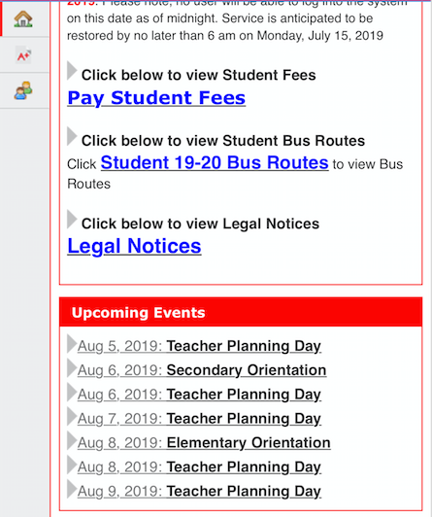

Activate your Parent Portal Account by selecting “Activate Account” on the screen. Enter the email address associated with your myStudent account and select “Send Email” which generates an email to activate the account. Go to your email and select the link. Continue by creating your password. Once this is completed, you will be able to see the school fees.

Step 3: After paying fees, return to the myStudent home screen. Complete the steps below to view the student schedule.

- Open the “My Child Tab” on the left side of the screen.
- Open the “Class Schedule” tab in the box that opens to the right.
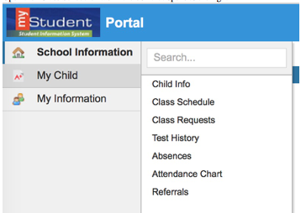
The classes listed are the current schedule for your child. These courses are connected to the fees that have been paid in Step 2. There is a way to print the schedule at the bottom of the screen. Note: Schedules may change prior to the start of the school year as we balance and level classes.

We will not be entertaining schedule change requests during the Orientation Day. You can access the form using the link below.
SCHEDULE CHANGE REQUEST

You have completed the virtual orientation for the 2019 – 2020 school year. Schedules will be printed out and distributed to students on the first day of school. Click on the link below for a map of the school. An alphabetical list of students with their first period teacher and room number will be posted throughout the school on Monday, August 12.
PVMS Map

Immunization Event Link
Dress Code link
Free and Reduced Lunch Link
Athletics link
School Advisory Council Interest Link
Jr. MYP Link
School Supply Lists

