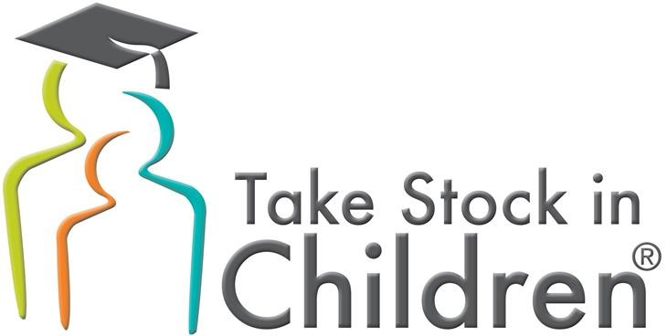

Your Child
may be eligible for a
College Scholarship
2019-2020
Your child may be eligible for a wonderful opportunity – a Take Stock in Children College Scholarship. Since 1997, Take Stock in Children, a program with the Pasco Education Foundation and supported by Pasco County Schools has helped students from economically disadvantaged families achieve the goal of going to college. Awarded to Pasco County’s undergraduates, the scholar’s progress is continuously monitored through college.
To be considered for this scholarship opportunity (up to four years tuition paid), your child must meet the income eligibility requirements, agree to remain crime & drug free, and have a minimum 2.5 GPA with good attendance. Up to two school reference forms are required. A mentor and a college readiness coach will be assigned.
The online application will be available on April 1, 2019 and closes on May 1, 2019. On April 1, 2019, the online application can be found at: www.pascoeducationfoundation.org. Review the requirements noted on the website carefully. If chosen you will be asked for detailed documentation of income.
Scholarship opportunities available are: (all scholarships require student to be eligble for free/reduced lunch status)
- Take Stock in Children – 8th graders only (minimum equivalent 2.5 GPA)

If any questions, please contact the Take Stock in Children Pasco County office at: rheyser@pascoeducationfoundation.org or 813-794-2134.

Take Stock in Children app notice_MS 2019-2020

