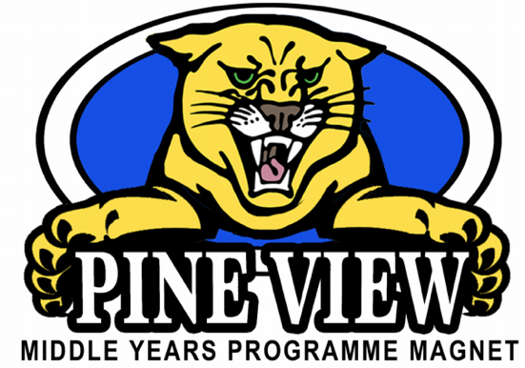
Year 1 Resources
Class of 2026
Language and Literature  - Audio Version of the Summer Reading: The Night Gardener by Jonathan Auxier  https://www.audible.com/pd/The-Night-Gardener-Audiobook/B00R1W9MQ8  - The Night Gardner pacing guide: https://pvms.pasco.k12.fl.us/class-of-2026/, then click on 2019-2020 Required Summer Reading and Pace Chart  - My HRW Textbook: available on My Pasco Connect in August | Individual and Societies  - CNN10 News: https://www.cnn.com/cnn10  - Dogo News: https://www.dogonews.com/  - Social Studies Games: http://www.primarygames.com/social_studies.php  - Social Studies For Kids: https://www.socialstudiesforkids.com/  - TCI Textbook: available on My Pasco Connect in August
Science  - Chemistry: http://www.middleschoolchemistry.com/  - CK12: https://www.ck12.org/student/  - Khan Academy: https://www.khanacademy.org  - Pearson Easy Bridge: available on My Pasco Connect in August  - Periodic Table: https://ptable.com/  - Scholastic: http://studyjams.scholastic.com/studyjams/jams/science/index.htm  - Simulations: https://phet.colorado.edu/en/simulations/category/new | Math  - Fact Monster: https://www.factmonster.com/math/flashcards#mul  - Khan Academy: https://www.khanacademy.org  - Open Up: https://im.openupresources.org/6/families/index.html
Language Acquisition  - American Sign Language: http://www.lifeprint.com/  https://www.handspeak.com/  https://www.signingsavvy.com/  http://fingerspell.net/#/  - Spanish: https://www.duolingo.com/ | Design and Arts  - Graphic Arts: https://method.ac/  - Band/Chorus: http://www.therhythmtrainer.com/  https://www.musictheory.net/lessons  https://www.classicsforkids.com/
All Subjects:
- My Pasco Connect (My Student, My Learning, Acorn, Textbooks, etc): https://launchpad.classlink.com/dsbpc
- PVMS: https://pvms.pasco.k12.fl.us/

Athletics:
- https://pvms.pasco.k12.fl.us/athletics/

Social Media:
- Facebook: https://www.facebook.com/PineViewMiddleSchool/
- Instagram: pvmsmyp
- Remind Class of 2026: Text @pvms2026 to 81010
- Twitter: @PineViewMiddle

