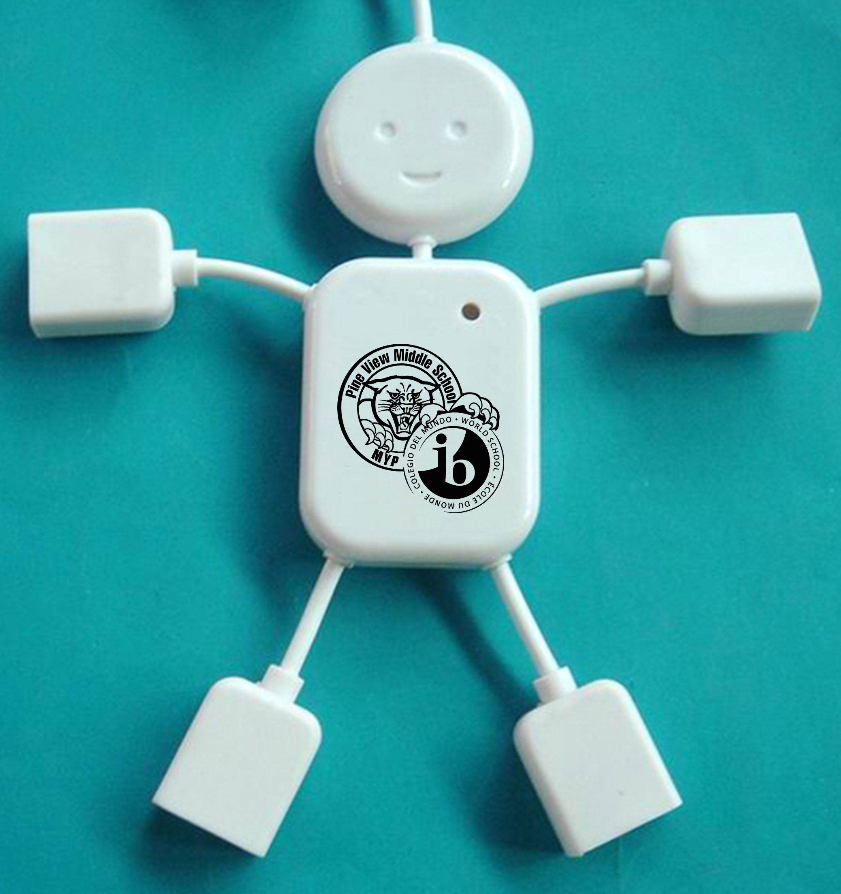

USB HUB GUY $10.00

## Limited Quantities

PVMS IB MYP