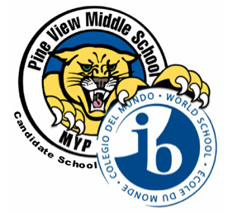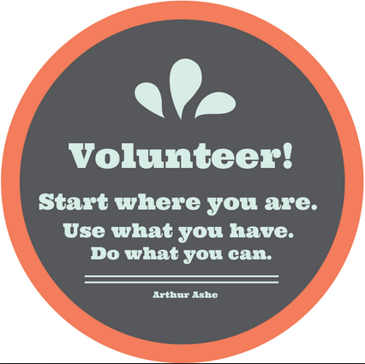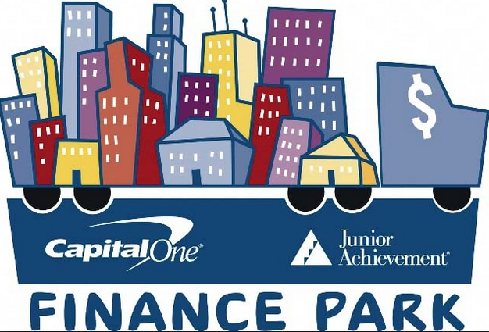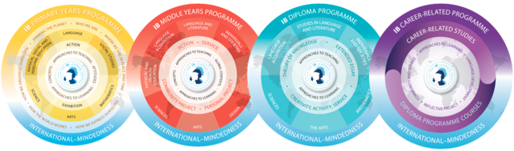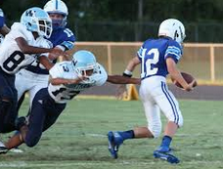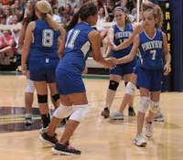

11/9 6:30-7:30pm IB Information Session  
at the LOLHS mini-  
theater

11/11 Veteran’s Day. Wear  
your red, white and blue!

11/16 Fall Music Concert Wesley Chapel High School @ 6:30.

11/17 Great American Teach-In at PVMS

11/20 Progress Reports

11/23- 27 Thanksgiving Break-   
No school

**December**

12/9-11 Winter One Act Plays  
Doors open at 6, show starts at 6:30. Tickets are $3 at the door.

November Learner Profile of the Month:  
Risk-taker

As a PVMS Family, we will focus on a different Learner Profile every month. For November, we are focusing on being *Risk-takers*. We are *Risk-takers* when we approach unfamiliar situations and uncertainties with courage and forethought. PVMS staff members have brown “#IBRisk-taker” tickets that they are giving out throughout the month to students who are *Risk-takers*. At the end of the month, all students who earned a ticket will be entered into a drawing to earn a prize. Teachers will also be choosing students for “student of the Month” who are an example to others in exemplifying that they are *Risk-takers*.

##### 5334 Parkway Blvd, Land O’Lakes, FL 34639

##### <pvms.pasco.k12.fl.us> T: 813.794.4800

**November**

#### Pink Out every Wednesday!

### Upcoming events

The Panther Press

# Pine View Middle School

No act of kindness, no matter how small is ever wasted. -Aesop

Thank you for your interest in volunteering at Pine View Middle School! There are many opportunities for approved volunteers in our school from chaperoning field trips to assisting in the classroom to supporting our incentive program by handing out rewards in the Panther Pit. If you are interested, please contact the school at 813-794-4800.

*Year Three Parents:*

We are in desperate need of volunteers for our field trip to Finance Park. Volunteers arrive early to Finance Park in Largo to be trained and work with a group of six students for a budget simulation activity. Students are going on the field trip through their History classes.

Monday- December 14th (Mr. Menendez’s classes)

Wednesday- December 16th (Mr. Hundt’s classes)

Thursday- December 17th (Mrs. Fuqua’s classes)

Volunteers must be approved. Please visit the district website and submit a volunteer application. Once you are approved, please email your child’s History teacher or Ms. Fink at [mfink@pasco.k12.fl.us](mailto:mfink@pasco.k12.fl.us). A schedule and directions will be sent to home a few days before the trip. Thank you for your assistance in making our field trip a huge success.

## **#IB Involved: Volunteer Opportunities!**

To learn more about Finance Park, please visit <http://www.stavrosinstitute.org/finance-park>

## Calling all volunteers!

Like the Middle Years Programme, the Diploma Programme (featured in the September newsletter) and the Career-Related Programme (featured in the October newsletter), the Primary Years Programme is about developing the whole child. The Primary Years Programme (PYP) was founded in 1997 and is one of the newer programmes on the IB spectrum. Students in the PYP are elementary students, aged 3-12. The PYP has a similar focus to the MYP in that trans disciplinary, inquiry-based work is the norm and a second language is one of the core academic areas.

The PYP nurtures independent learning skills, encouraging every student to take responsibility for their learning.

The programme incorporates local and global issues into the curriculum, asking students to look at six related, trans disciplinary themes and to consider the links between them. The themes are:

-Who we are  
-Where we are in place and time  
-How we express ourselves  
-How the world works  
-How we organize ourselves  
-Sharing the planet

For more information regarding the Primary Years Programme or any of the four IB programmes,, please visit <http://www.ibo.org>.

# What other programmes does the IB offer? Primary Years Programme focus

**#IBInvolved Results**

**Thank you for making a difference!**

**Canned food:** Pine View collected **340 food items** to assist families during the holidays.If you would like to make a difference for one of our students or families during the holidays, please contact our guidance office at 794-4830.

**Treats for Troops:** We collected a total of 211.75 pounds of candy to donate to our troops.  
 Year 1 students: 76 lbs  
 Year 2 students: 63.5 lbs  
 Year 3 students: 72.25 lbs

**Socktober:** PVMS students donated 150 pairs of socks. Go Panthers!

**PVMS Social Media and Helpful Links**

PVMS Website: <pvms.pasco.k12.fl.us>

Instagram: pvmsmyp

Twitter: @pineviewmiddle

Facebook: Pine View Middle School

[International Baccalaureate](http://www.ibo.org)

Our Girls Basketball and Boys Soccer teams have begun their season! Please see our school calendar for practice and game schedules on the PVMS website.

Come on out to cheer on our Panthers!

**Athletics**

A HUGE thank you to the local businesses that support PVMS. If you own a business or know of one who would like to support our school, please contact [Becky Cardinale.](mailto:rcardina@pasco.k12.fl.us)

***Thank you*** to our supporters:

**Optimum Plumbing**- Thank you for your very generous gift card donation for our Students of the Month!

**Wendy’s-** Thank you for the Super Student Awards and Frosty coupons!

**Cobb Theatres-** Thank you for the complimentary movie passes!

**Lake Wilderness Beef O’ Brady’s-** Thank you for the Merit and Achievement Awards!

**Moe’s Southwest Grill Land O’ Lakes-** Thank you for the certificates and the supplies!

**McDonald’s- Land O’ Lakes (and partner restaurants)**- Thank you for the Chicken McNugget vouchers!

**Sugardarlings Cones and Cupcakes**- Thank you for the cupcake vouchers!

Support our Supporters!