STUDENT NAME: ____________________________
Pine View Middle School STUDENT NUMBER: ________________________
2016-17
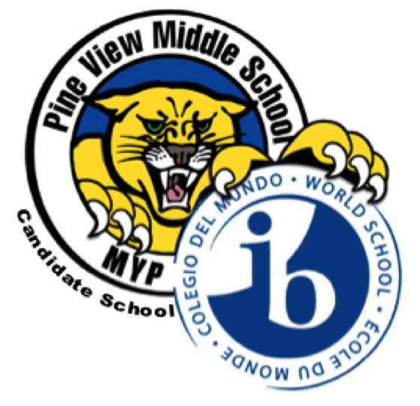
Year 3 (8th grade)
XX Students Are Automatically Placed

Year 3 Requirements:

XX Language & Literature (English Language Arts 3)
XX Comprehensive Science 3
XX Individuals & Society (US History)
XX Pre-Algebra

Placement in Advanced classes will be based on FSA Scores, Quarterly Checks, Teacher Recommendation, District Matrix and Class Size.
If the student is required to take Intensive Reading per Florida State Legislature it will take place of Language Acquisition.

Choose one (1) course from each of the boxes below and mark it with an “X”.
You must have had Beg Spanish to select Intermediate Spanish; Spanish 1 to select Spanish 2;
Chorus 1 to select Chorus 2; Chorus 2 to select Chorus 3; Beg Band to select Intermediate Band;
Intermediate Band to select Advanced Band and Drama-Theatre 1 to select Drama-Theatre 2
Select one (1) alternate from each of the boxes below and mark it with an “A”.
ARTS
Chorus 1 __________
Chorus 2 __________
Chorus 3 __________
Beg Band __________
Intermediate Band __________
Advanced Band __________
Art __________
Drama-Theatre 1 __________
Drama-Theatre 2 __________

LANGUAGE ACQUISITION

Beginning Spanish ________
Intermediate Spanish ________
Spanish 2 ________

ASL* (Online) ________
*American Sign Language
DESIGN

Agriculture/PE __________
Culinary/PE __________
Graphic Arts/PE __________
Technology/PE __________

Course Selection Notes: Selection of a course above does not guarantee placement in the course.
Recovery may be assigned to a student in lieu of an Arts or Design class based on FSA test scores.

Due to State grade level requirements, class size and EOC exams, schedule change requests will be

very difficult to honor and will require Administration approval to ensure stability for all students at

Pine View Middle School.

I am aware of the above choices that I have selected and agree to not making changes after this point.

______________________________

Student Signature

I, the parent/guardian, also agree to what was decided above. ______________________________

Guardian/Parent Signature

The PVMS School Counselors are available to answer any questions at (813) 794-4830

Course Cards Due No Later than: April 22, 2016

