STUDENT NAME: ______________________
Pine View Middle School STUDENT NUMBER: ______________
2016-17
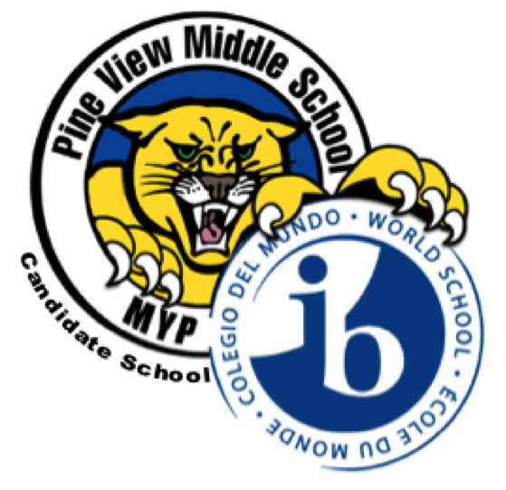
Year 1 (6th grade)
XX Students Are Automatically Placed

Year 1 Requirements:

XX Language & Literature (English Language Arts 1)
XX Comprehensive Science 1
XX Individuals & Society (US History) _________________________
XX Mathematics 1 Parent Signature

Placement in Advanced classes will be based on FSA Scores, Quarterly Checks, Teacher Recommendation, District Matrix and Class Size.
If the student is required to take Intensive Reading per Florida State Legislature it will take place of Language Acquisition.

Choose one (1) course from each of the boxes below and mark it with an “X”.
Select one (1) alternate from each of the boxes below and mark it with an “A”.
DESIGN

Agriculture/PE __________
Culinary/PE __________
Graphic Arts/PE __________
Technology/PE __________

If a 7 period day is not passed please circle which class is your preference:

ARTS OR DESIGN
LANGUAGE ACQUISITION

Beginning Spanish ________

ASL* (Online) _________
*American Sign Language
ARTS

Chorus 1 __________
Beg Band __________
Art __________
Drama-Theatre __________
DUE TO STATE GRADE LEVEL REQUIREMENTS, CLASS SIZE AND EOC EXAMS, SCHEDULE CHANGE REQUESTS WILL BE VERY DIFFICULT TO HONOR

Description of Arts & Design:

Chorus 1: This course provides a variety of singing opportunities for students with limited formal choral experience. Vocal techniques and music reading are emphasized, and students are given the opportunity to explore various musical sources and styles. Participation in various performance opportunities is a requirement of the class.

Beginning Band: Students with little or no instrumental experience develop foundational instrumental technique, foundational music literacy, and aesthetic musical awareness through rehearsal, performance, and study of high-quality band literature. Attendance at after school rehearsals and performances is required.

Art: This emphasizes the elements of art, some design principles and competence in a variety of 2-D and 3-D Media. The structure is more stringent than elementary school and there are formal assessments on projects as well as written tests.

Drama-Theatre: The purpose of this course is to enable students to gain knowledge and skills in the basic elements of theatre, including acting, directing, playwriting, and theatre history and literature. Students may be required to attend or participate in rehearsals and performances outside the school day.

Agriculture: Exploration of career opportunities and job-required tasks performed in a broad range of agricultural occupations. Paired with Culinary for Year 2.

Culinary: Exploration of career opportunities, food safety and sanitation; safe and proper use of culinary tools/equipment; interpreting recipes and basic food preparation skills. Paired with Agriculture for Year 2.

Technology: Exploration of production technology and its associated careers. Paired with Graphics for Year 2.

Graphic Arts: Exploration of careers in the Arts, A/V Technology & Communications. Paired with Technology for Year2.

Physical Education: Physical education provides students with the knowledge and skills necessary to perform a variety of physical activities, to maintain physical fitness, and to value as well as enjoy physical activity as an ongoing part of a healthy lifestyle. Physical education includes curriculum, instruction and assessment

